Getting to Misano Adriatico : What do I need to know?

- From the Airport to the Train Station
- Train Travel in Italy
  - Purchasing Tickets from the Trenitalia Website
- Finding the Hotel Imperial
- Important Contact Numbers

From the Airport to the Train Station

If you are flying into Bologna: To get from the airport to the train station, you can either catch a taxi (€15/20) or the BLQ Airbus (€6). The Airbus runs every 20 minutes and the very last stop is Bologna Centrale Station. You can find the Airbus stop right outside the airport doors, but if in doubt ask anyone; the service is well known, so someone will be able to point you in the right direction.

If you are flying into Rome Fiumicino: You have three options for getting from the airport to the Roma Termini train station. The first is to catch the Leonardo Express train (a 30-minute journey); signs in the airport will direct you toward the tracks and ticket station. Alternatively, you could choose bus service into the city; Terravision offer this service, amongst others. Your third options would be to take a taxi (approx. €50).

If you are flying into Milan Malpensa: There is a bus service right outside the airport which will take you to the Milano Centrale train station. From there, you will need to catch a train from Milan to Bologna then Bologna to Riccione/Misano based on availability.

If you are flying into Rimini: The best option is a taxi. An agreement is in place with the local taxi service to provide transportation to the Hotel Imperial for €30. Please write to Ashley to book a taxi under this agreement (prices may be higher if you just hop in a taxi outside the airport).

Train Travel in Italy
Travel by train in Italy is very convenient, but here are a few important things for you to remember:

- Remember to purchase a ticket prior to boarding the train. You cannot purchase tickets on the train, and if you board without one, you will be fined.

- Remember to validate your ticket by punching it in one of the machines on the platform or in the station lobby. Before you board the train, the machine will punch the date and station onto your ticket. Although this is compulsory only for certain types of tickets/trains, in order to avoid the risk of a fine, we strongly advise you to punch whatever ticket you may have, even if you think the date is already clearly indicated.

- Remember that there are different kinds of trains in Italy. The less expensive trains (called ‘regionale’ or ‘regionale veloce’) are run by the state and have a fixed price, regardless of the time or date of travel. They are slightly slower, but they stop at all stations (including the smaller, secondary ones like Misano). Other trains (e.g. Intercity, Italo, Interregionale) are run by private entities and ticket prices vary according to availability and date of purchase. While they are often faster and run very frequently, they are also more expensive and stop only at main stations (i.e. not Misano).

- Remember that Misano is a small station, not always well serviced. If there is no train to Misano available at the time you require, do not panic! If you are travelling from Bologna, get off at Riccione (one station north of Misano). If you are travelling from Rome, get off at Cattolica (one station south of Misano). In either case, there is a taxi service just outside and the Hotel Imperial will be only 10 minutes away (€10/15).

- Remember that if you are travelling from Rome, you will need to change trains. You can choose to transfer either at Bologna Centrale or in Falconara Marittima. Please write to Ashley Brown (ashley.brown@fusp.it) directly if you have any questions or doubts about trains from Rome.

Purchasing Tickets from the Trenitalita Website
While it is possible to purchase tickets on the day of travel at the ticket counter of any major train station (using Euros or a credit card), some of you may prefer to purchase your tickets ahead of time from the Trenitalia website (http://www.trenitalia.com/). Because the site is not always very user-friendly, here are some directions to help you on your way.

- This is Trenitalia’s homepage.

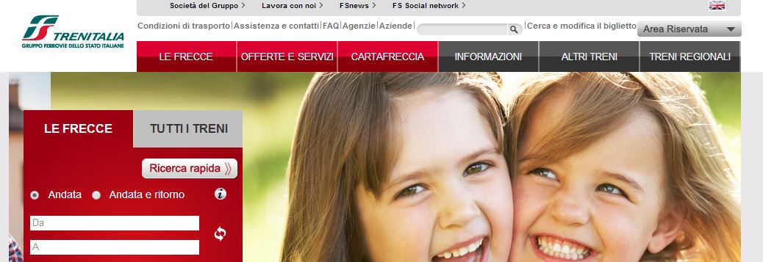

- Switch to English by clicking in the top right hand corner. Once you have done this you should have the following view:

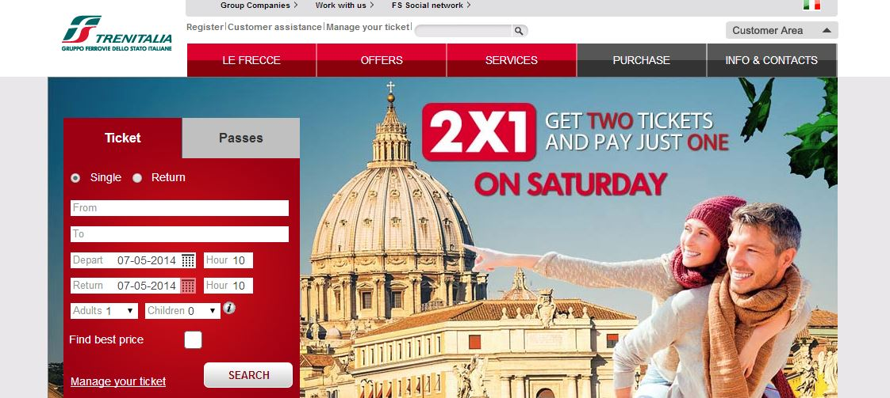

- In the “Tickets” sections, insert full name of stations (so not simply Bologna, but Bologna Centrale), as well as the relevant date and times, like so:

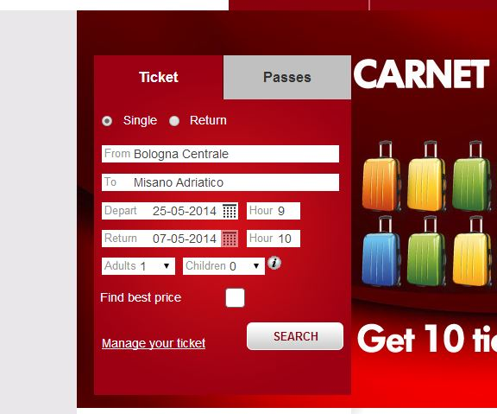

- Once you’ve done this hit “Search” and all the trains available will appear. Based on your preference and time of arrival you can choose to purchase whichever train best suits your needs:
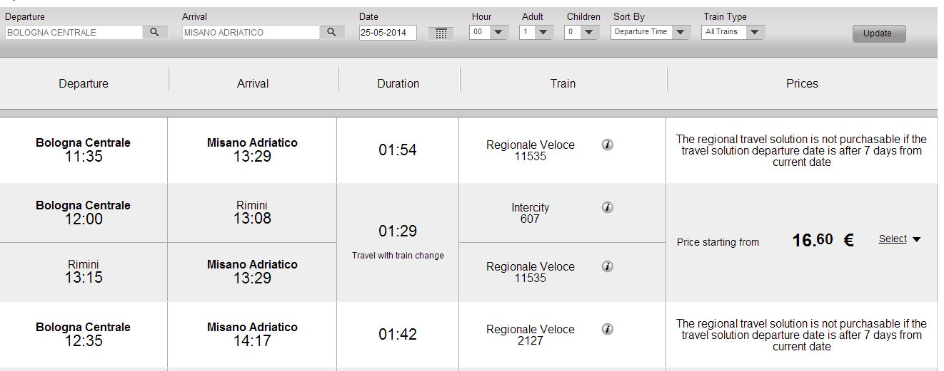

**IMPORTANT NOTE: All the types of train tickets are available for purchase online. However, regional train tickets, which are not subject to price changes, are available only 7 days before the journey.

Finding the Hotel Imperial
Due to the number of participants arriving from all different directions and at all different times, Nida staff are not able to meet individuals at airports or train stations. However, it should not be difficult for you to get to the hotel where we will be waiting to greet you. If you are arriving at Riccione or Cattolica, you should be prepared to provide a taxi driver with the address of the Hotel Imperial (Via Litoranea Sud, 50), approximately 10 minutes away. If, on the other hand, you are arriving at the Misano train station, it is an easy walk to the hotel (only about 1 kilometre / 0.62 miles). Unless you are travelling with a great deal of luggage, this may be the easiest way for you to get there. The route can be seen on the map below.

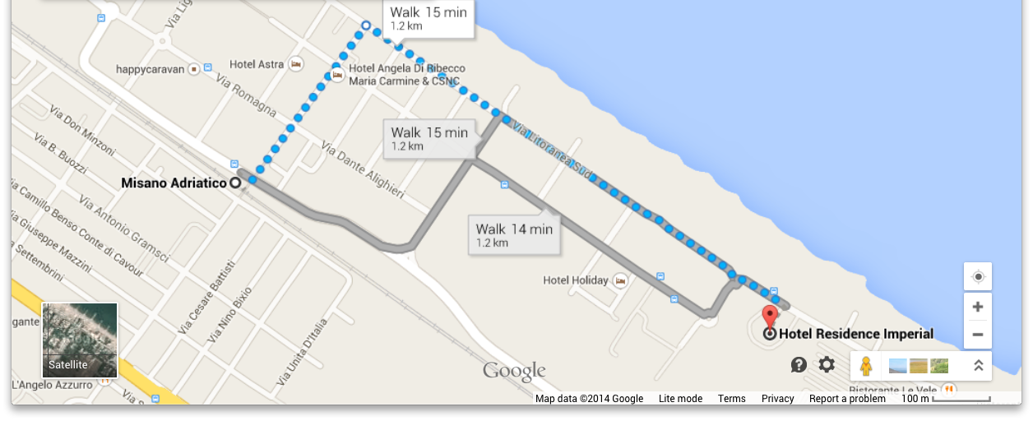

Important Contact Numbers
In the event that you get stuck or lost, please do not hesitate to telephone our project manager, Ashley Brown: +39 3201536912

The hotel address and phone number are as follows:
Residence Imperial
Via Litoranea Sud, 50
47843
Misano Adriatico (Rn)
Tel. +39 0541/610114

Have a safe journey!

